 | CTRC Generic Randomisation System  User Guide – Role: Researcher  Original Author: Keith Kennedy.  Version 1.0

Introduction
The CTRC Generic Randomisation System allows randomisation within trials managed by the CTRC.
This user guide covers randomisation only.
Contents
1. Introduction 1
2. Important Notes You Must Read 2
2.1. Identifying Development/Test Site compared to Live Site 2
3. Access Guidelines 2
4. Pages 2
4.1. Login 2
4.2. Randomisation Form 2
Confirmation before randomisation 4
Confirmation of Randomisation 4

Important Notes You Must Read

Identifying Development/Test Site compared to Live Site
All pages on the development site will contain a red heading indicating that the site is the development site. The live site will not contain this header.
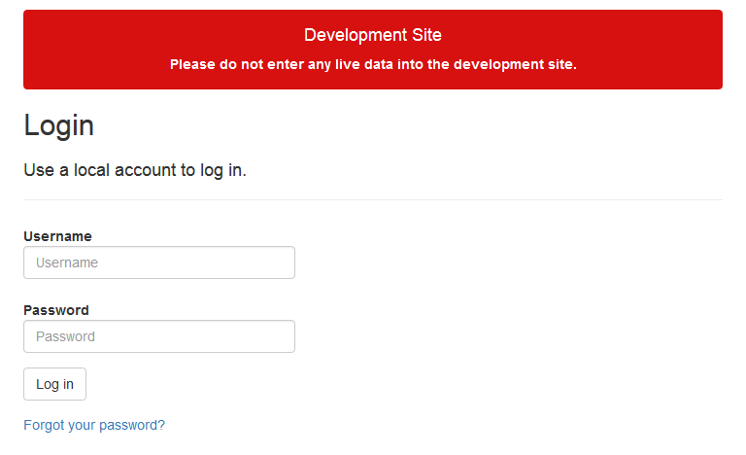
Figure 1 - Login page with Development Site Indicator

Access Guidelines
Only users that have received appropriate training and that are on the site delegation log should access the live randomisation system.

Pages

Login
You should have received access credentials from your trial co-ordinator for access to the randomisation system. Please use these on the login screen to login.
If you cannot remember your password, the “Forgot your password?” link will open a page where you can enter your username. This will send you an email detailing how to reset your password.
If you cannot remember your username or you do not receive an email within 2 hours, please contact your trial co-ordinator.
Once logged in, you will be directed to the randomisation page.
For security, passwords should not be stored for this page on any computer or computer user account which does not require a password to access.

Randomisation Form
Upon login you will be directed to the randomisation page. The page will contain a form, which will contain a series of questions. All questions are mandatory.
An example is included below (please note that the text of the questions will differ based on your trial):
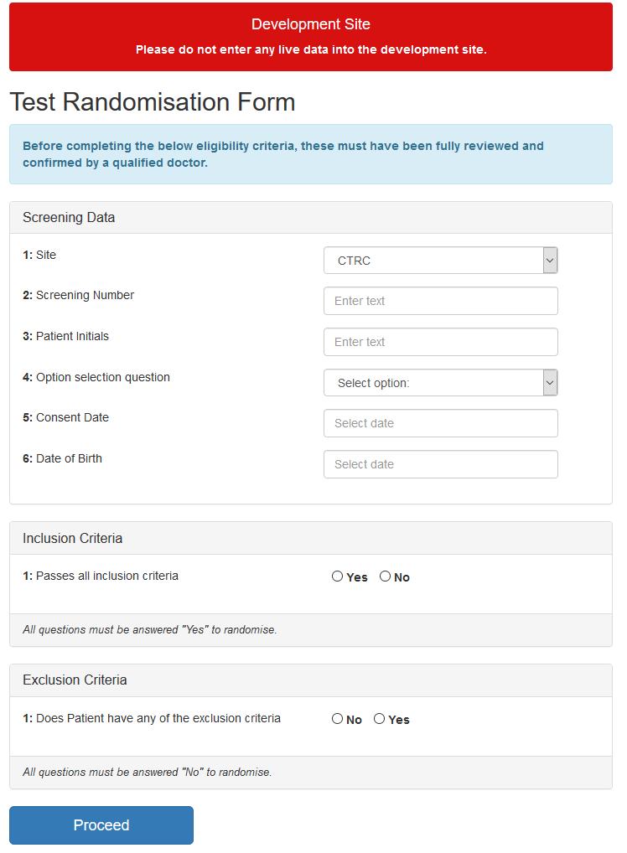
Figure 2 - Example Randomisation Form
Questions will contain validation rules that must be adhered to. A typical example is that the “Date of Birth” cannot be a future date. If any validation rules are violated, then you will be notified within the webpage.
Figure 3 - Example of Rule Violation

Confirmation before randomisation
Once the form is completed, pressing “Proceed” will display a confirmation window.
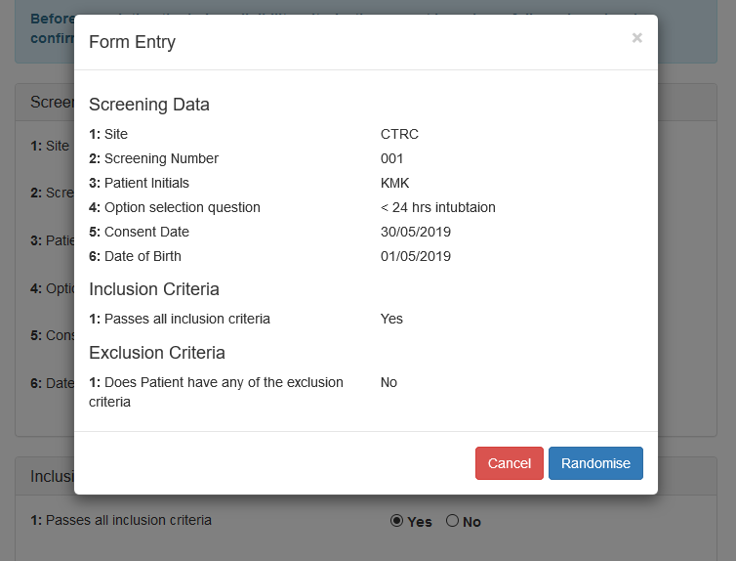
Figure 4 - Randomisation Data Confirmation
If you are happy with the data, press “Randomise”. If you are not, press “Cancel” and update the form.

Confirmation of Randomisation
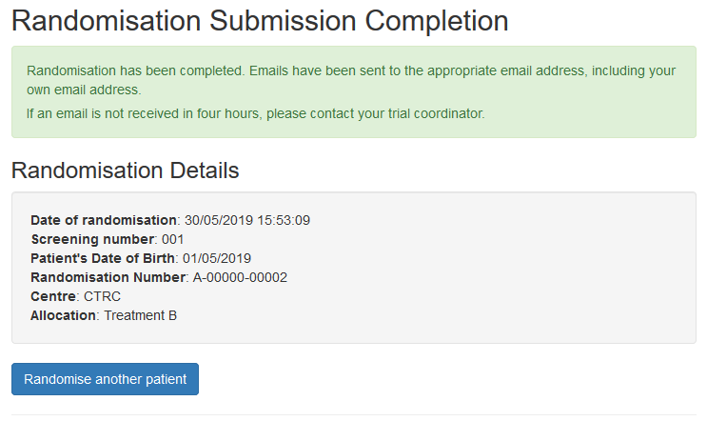
Figure 5 - Randomisation Confirmation
Once randomisation is complete you will see the above page, this page will display the assigned randomisation number. (Please note that allocation will only appear if the system is set to “unblinded”, if your trial is blinded you will not see the allocation data).
Randomisation is now complete; you may randomise another subject or logout of the system.

